44.14: a) 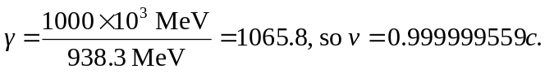
b) Nonrelativistic:
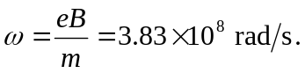
Relativistic:
